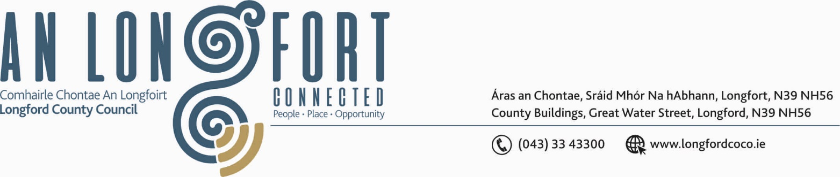

LONGFORD MUNICIPAL DISTRICT

Please note meeting will be held via Microsoft Teams.

18th February 2021.

To: Each Member of Longford Municipal District.

Dear Member,

You are requested to attend Meeting of Longford Municipal District to be held
via Microsoft Teams on Wednesday, 24th February 2021 4.30 p.m. to transact business, as set out on the Agenda hereunder.

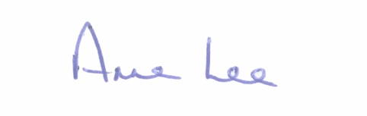
Yours sincerely,

_______________
Anne Lee,
Meetings Administrator.

AGENDA

Prayer before meeting.

- Confirmation of Minutes of meeting of Longford Municipal District held on
the 27th January 2021 - copy enclosed

- Matters arising from Minutes.

- Declaration of Interest by Members.

- Management Report – to follow.

- Notices of Motions, submitted by Councillors, as listed hereunder –

Councillor John Browne.

“I call on Longford County Council to send the Road Sweeper to Newtownforbes and Drumlish once a month to undertake a clean-up.”

Councillor Gerry Warnock.

“I am calling on Longford MD to carry out works to secure the boundary between The Longford Royal Canal Walk and Farneyhoogan Estate. The deterioration of the hedgerow between the estate and the canal walk has turned into a “rat run” that has resulted in an exponential growth in antisocial activity in the area at great annoyance and distress to some of the more vulnerable residents. I would suggest a combination of durable fencing and native hedgerow planting be used as secure boundary treatment.”

Councillor Gerry Hagan.

“I call on Longford MD to Erect place name signs at Shroid and Corboy”



